Mayan Garden Club Tip of the Month- Native Plants- December 2017

Crinum Augustum- one of about 180 species of Crinum which thrive in subtropical and tropical regions. These plants will grow almost anywhere they have enough water. They will flourish in marshes, swamps, sandy areas, wetlands and in your garden.

- Crinum plants can reach 5 feet tall and are one of the hardiest lilies.

- Crinums grow best if exposed to full sunlight.

- Crinum lilies need nutrient-rich soil. Enrich your soil with organic material about a foot down before planting. After this, these plants will tolerate almost any type of soil.

- These plants are heavy feeders and will benefit from regular feeding as well as organic mulch. Fertilize once a month with food made for flowering bulbs during the plant's first year. After that, fertilize once or twice a year.

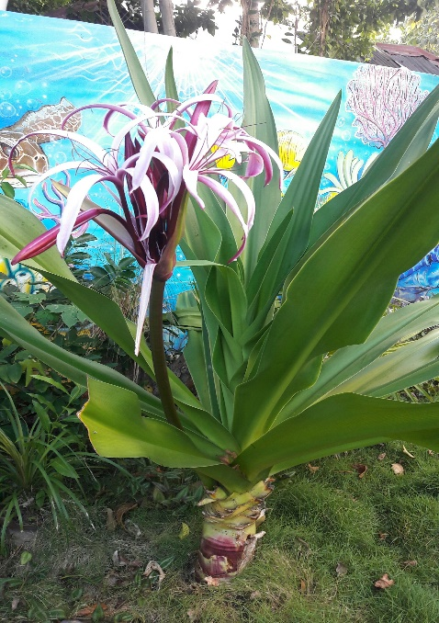
- Water first-year crinums at least once a week if it does not rain. Try to avoid wetting the leaves, as this can lead to leaf spot, a fungal disease. After the first year, only water when there are extended periods of drought.

- These plants do need the occasional grooming of leaves after they start touching the ground.

